Project Design Phase-II

Technology Stack (Architecture & Stack)

Technical Architecture:

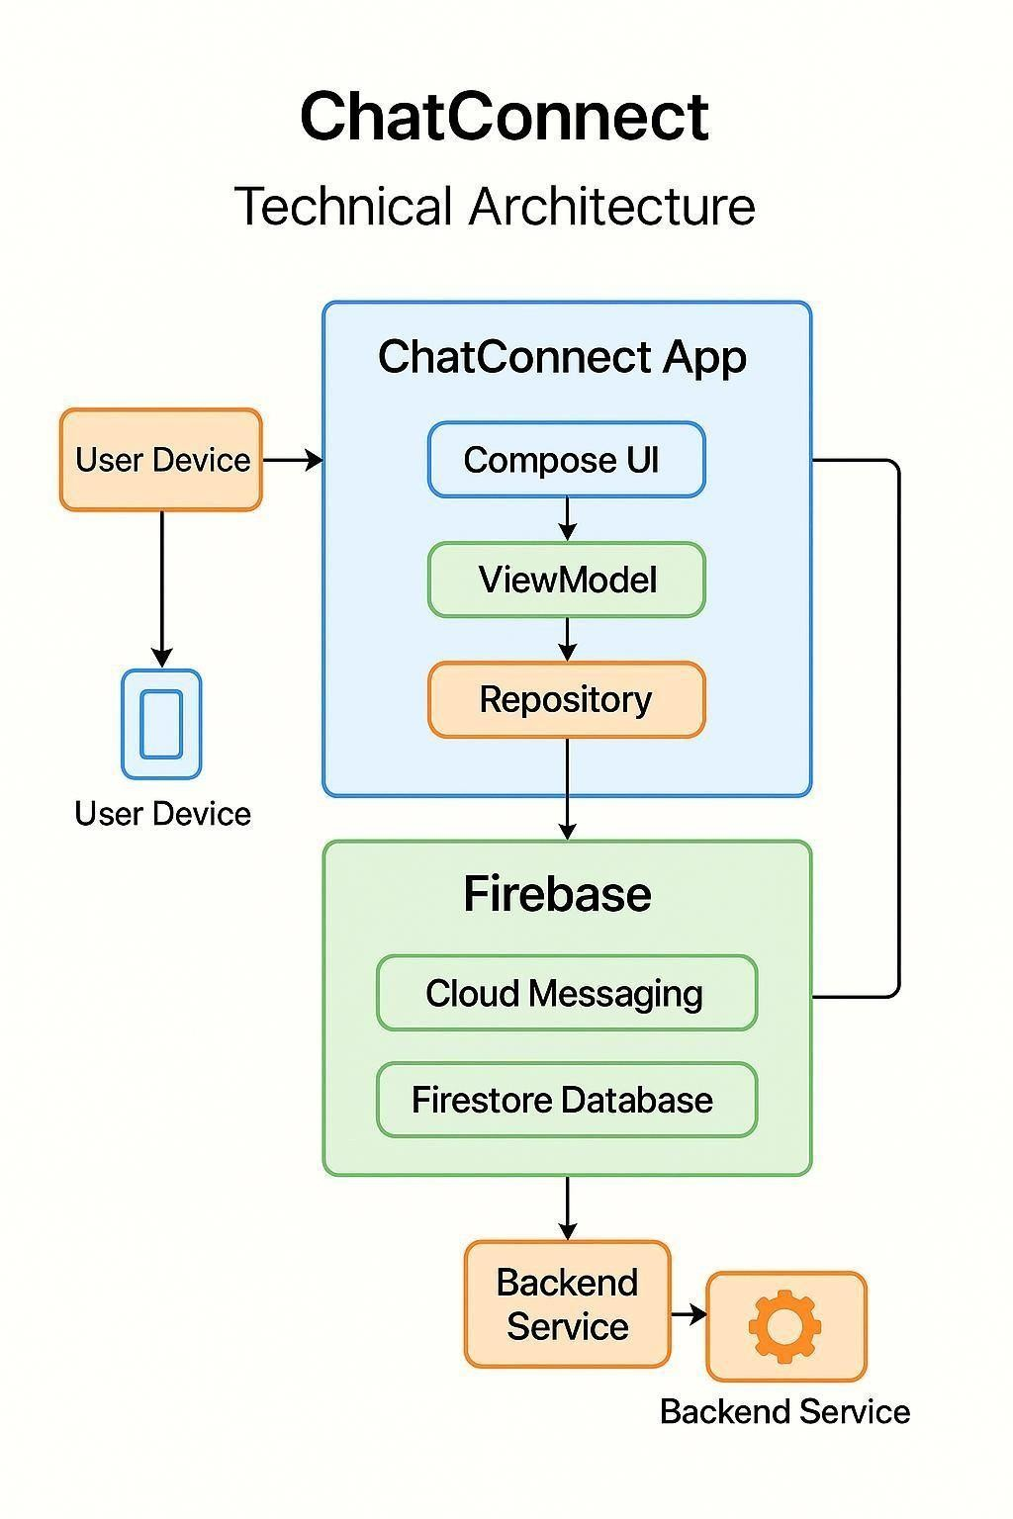
Table1: Components and Technology:

S.No | Component Description | Technology
1 | User Interface | Jetpack Compose (Android), Kotlin, Material Design
2 | Authentication & User Management | Firebase Authentication
3 | Chat Messaging | Firebase Cloud Firestore, Firebase Cloud Messaging (FCM)
4 | Media Upload and Storage | Firebase Storage
5 | Notification System | Firebase Cloud Messaging (Push Notifications)
6 | Chat Room Management | Firestore (for real-time updates and syncing), Kotlin
7 | Navigation & Routing | Jetpack Navigation Component
8 | Backend Services (Optional for Extensions) | Firebase Functions (for custom  logic like analytics or moderation)
9 | Analytics & Crash Reporting | Firebase Analytics, Firebase Crashlytics
10 | Deployment & CI/CD | Google Play Console, GitHub Actions (optional for CI/CD)
Table2: Application Characteristics:

S.No | Application | Characteristics
1 | User Interface | Responsive UI, built using Jetpack  Compose; intuitive and adaptive layouts
2 | Authentication & User Management | Secure login/signup with Firebase Auth; supports email/password and OAuth
3 | Real-Time Messaging | Instant message updates via Firestore; supports emojis, text, images, videos
4 | Media Upload and Storage | Efficient file storage and retrieval via Firebase Storage; scalable & secure
5 | Notifications | Push notifications via FCM; real-time alerts for new messages or mentions
6 | Chat Room Management | Dynamic chat room creation/joining with Firestore sync; supports custom groups
7 | State Management | Real-time UI state updates using Compose ViewModel & State APIs
8 | Navigation & Routing | Smooth screen transitions via Jetpack Navigation Component
9 | Backend Services (Optional) | Serverless logic using Firebase Functions; extendable for analytics/moderation
10 | Analytics & Crash Reporting | Usage insights via Firebase Analytics; realtime crash logging with Crashlytics

